|  |  |  |
| --- | --- | --- |
| **Tech Saksham**  Final Project Report  **Full Stack Web Development** |  |  |

**“Online Outpass System”**

**“Rajiv Gandhi University of Knowledge Technologies, Kadapa”**

|  |  |
| --- | --- |
| **ROLL NO** | **NAME** |
|  |  |
| R170566 | S.Madhavi |
| R170610 | K.Safiya |
| R170568 | D.Praneetha |
|  |  |
|  |  |

Poovaragavan Velumani

|  |  |
| --- | --- |
|  |  |
|  |  |
|  |  |

**ABSTRACT**

Out-pass is a permission that is given to students to go out of hostel mainly in Institutions. Currently many hostels are following manual work i.e., Student need to visit the Warden/Care taker office by in person. Our project is to reduce that manual work and paper usage by providing an online environment where Students can apply for out-pass and Wardens and Care takers can also easily accept or reject Students out-pass through this portal. The Out-passes history will be stored in database. So, the institute can check that details when they required.

**INDEX**

|  |  |  |
| --- | --- | --- |
| **Sr. No.** | **Table of Contents** | **Page No.** |
| 1 | Chapter 1: Introduction |  |
| 2 | Chapter 2: Services and Tools Required |  |
| 3 | Chapter 3: Project Architecture |  |
| 4 | Chapter 4: Architecture Blocks Detail Working |  |
| 5 | Chapter 5: Project Budget |  |
| 6 | Conclusion |  |
| 7 | References |  |
| 8 | Code |  |

**CHAPTER 1**

**INTRODUCTION**

* 1. **Overview**

The Online Out-pass System (OOS) for to reduce the hassle the students have to go through while getting permission from respective authorities (warden/care taker) before leaving the hostel campus and reducing the wastage of time. This application helps in eradicating the use of paper, hence saving the environment and trees.

* 1. **Feature**

The main aim of this system is issuing outpass for the students who are in the educational institutions with attached hostels.

* 1. **Scope**

This system allows the warden/care taker to maintain the out-pass records and accept or reject the out-pass applied by the student. And also allows the student to apply/register for the out-pass easily.

* 1. **Future Work**

This system allows the students can easily apply/register for the outpass from the wardens by using this web application.

**CHAPTER 2**

**SERVICES AND TOOLS REQUIRED**

**2.1 Tools and Softwares used**

Front-End : HTML5,CSS3 AND JAVASCRIPT

Back-End : PHP

Database : MySQL

Tool : VS Code Editor,XAAMP Server.

**2.2.1 NodeJS**

Node.js is an open-source, cross-platform, back-end JavaScript runtime environment that runs on a JavaScript Engine and executes JavaScript code outside a web browser, which was designed to build scalable network application.

**2.2.2 HTML**

HTML stands for the Hyper Text Markup Language. HTML is the standard markup language for Web pages. HTML elements are the blocks of the HTML Markup. HTML elements consist of start tag,end tag and content in between them.

**CHAPTER 3**

**PROJECT ARCHITECTURE**

**3.1 Architecture**

**USER FRONTEND BACKEND**

|  |  |  |
| --- | --- | --- |
|  | **HTML 5** | **NODEJS 14.0**  **Database** |

**CHAPTER 4**

**ARCHITECTURE BLOCKS DETAIL WORKING**

**4.1 Blocks**

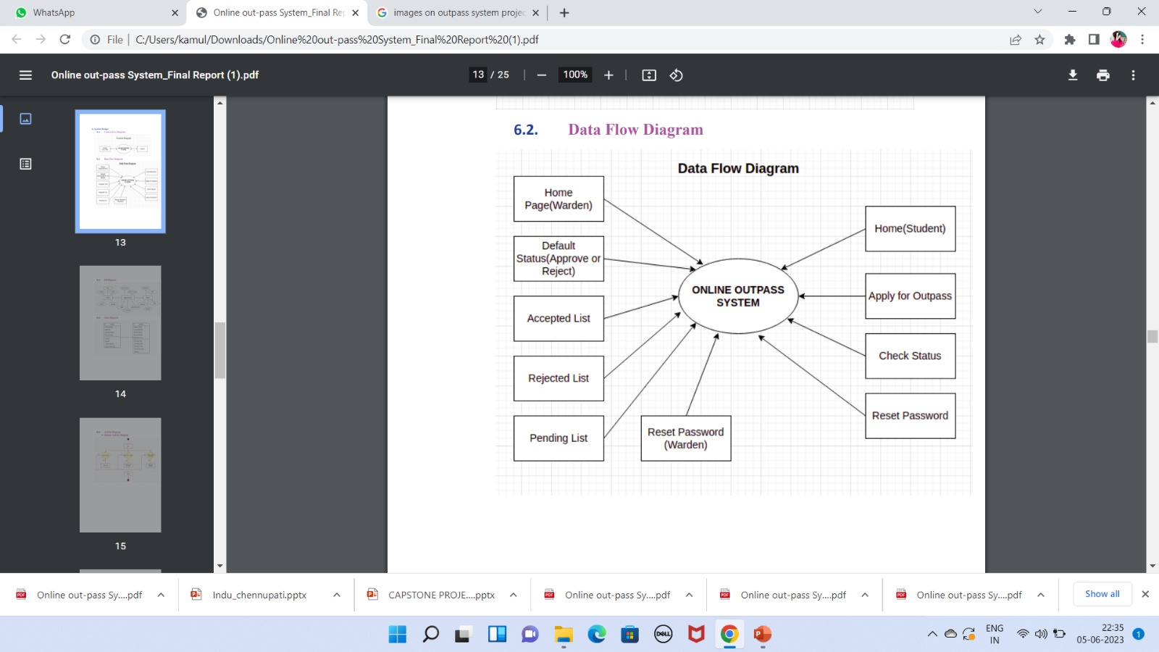

**CHAPTER 5**

**PROJECT BUDGET**

* **This project is build by taking reference from different websites and with the help of trainer. No external resourced were bought to complete the project**

**CONCLUSION**

The aim of the project is to make a complete, fully working web based outpass system for hostel. System to improve hostel’s everyday outing management and to increase working efficiency.

Data storage and retrieval will become faster and easier to maintain. User is provided the option of only view the records he entered earlier. This system can be commercialized

**REFERENCES**

* http://google.com
* https://www.tutorialspoint.com
* https://www.wikipedia.org
* https://stackoverflow.com
* https://www.w3schools.com

**CODE**

**Git Hub Repo Link:** https://github.com/prani287/Techsaksham